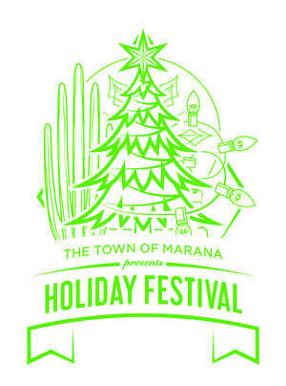
THE TOWN OF MARANA
presents
HOLIDAY FESTIVAL & CHRISTMAS TREE LIGHTING
SATURDAY, DECEMBER 2, 2023 | 3-9PM

Marana Municipal Complex
11555 W. Civic Center Drive, Marana, AZ 85653

SCHEDULE OF PERFORMANCES

SANTA CLAUS & MRS. CLAUS ARRIVAL PARADE at 2:45PM
2:45PM – Santa and Mrs. Claus will be escorted by Marana PD, Marana High School Marching Band, Cheerleaders and Holiday characters starting at Marana Main Street & Bill Gaudette and ending at to their location in Santa’s Courtyard

CANDY CANE STAGE FROM 3PM-9PM
3:00PM – Marana Youth Choir
3:30PM – Marana High School Dance Team
4:00PM – Mariachi Rayos del Sol de Tucson High
4:30PM – Centre Stage Dance Studio
5:00PM – Compañía de Danza Folklórica Arizona
5:30PM – ShowBiz Academy of Dance
6:00PM – TREE LIGHTING & SHOW AT THE MMC PLAZA
6:30PM – Mountain View High School Dance Line (JV & Varsity)
7:00PM – Project 520 Dance Studio
7:30PM – BC Dance
8:00PM – BC Dance
8:30PM – TREE LIGHTING & SHOW ENCORE AT THE MMC PLAZA

SANTA’S COURTYARD STAGE FROM 3PM-9PM
3:00PM – Marana High School Marching Band
3:30PM – Marana High School Jazz Ensemble
4:00PM – Leman Academy of Excellence Choir
4:30PM – Marana High School Chamber Orchestra
5:00PM – Arizona Rose Arts Academy
6:00PM – TREE LIGHTING & SHOW AT THE MMC PLAZA
6:30PM – Znora Band
7:00PM – Znora Band
7:30PM – Mountain View High School Jazz Combo
8:00PM – Southern Arizona Spirit Squad
8:30PM – TREE LIGHTING & SHOW ENCORE AT THE MMC PLAZA

