OPTION 1: PAY THE FINE BY MAIL

I hereby waive my right to a hearing, lose the privilege to attend Defensive Driving School, and do not have to appear in court.

I understand that the court will enter a responsible plea and will report the finding to MVD. Points may be assessed to my driving record for any moving violations.

________________________________________________________
Defendant Name (Please Print)
________________________________________________________
Address
________________________________________________________
City, State Zip Code Phone Number
________________________________________________________
Defendant Signature Date

COURT DATE __________________________________________

COMPLAINT/CITATION NUMBER

CHARGE FINE AMOUNT
A.______________________ $_________________
B._______________________ $_________________
C._______________________ $_________________
D._______________________ $_________________
E._______________________ $_________________
REQUIRED – You must add $35 fee imposed per citation
MARANA TOWN ORDINANCE 5-6-1B(4) $35
If paid after court date, add $20 time
payment fee per ARS 12-116 $20

TOTAL AMOUNT DUE $_________________
If more than 30 days have passed since your arraignment contact the court prior to making your payment. Your driver’s license may be suspended, and your case may be in collections.

METHOD OF PAYMENT – (Payable to: Marana Court)

☐ Money Order ☐ Cashier’s Check ☐ Check

A $25 fee will be added for returned checks for non-sufficient funds.

Pay online at www.maranapayments.com
Or make your payment over the phone by calling
Toll Free (855) 619-0154

If paying by mail Detach and Mail this page with a copy of
your complaint.

OPTION 2: ATTEND DEFENSIVE DRIVING SCHOOL (DDS)
Arizona statutes allow you to remove one traffic violation from your driving record every year by completing Defensive Driving School (DDS). You must enroll and complete DDS seven (7) days prior to the court date listed on your complaint. If you need an extension, please contact the court. Any individual who commits a violation resulting in death or serious injury is not eligible to attend a defensive driving class. If you have a commercial driver’s license you are not eligible to attend a defensive driving class.

To determine eligibility, go to
www.Azdrive.com
Or call 1-888-334-5565.

OPTION 3: REQUEST A HEARING BY MAIL

If you choose to deny responsibility for the violation(s) you may request a court hearing by mail. We must receive your request on or before the court date listed on your complaint.

If you request a hearing you give up the option of attending Defensive Driving School (for that violation).

You may voluntarily post a deposit (cashier’s check or money order) in the amount of the fine and fees to ensure your license is not suspended should you fail to appear on your scheduled hearing date. (Follow payment instructions under PAY THE FINE BY MAIL) but submit Option 3 Form. If the Judge rules in your favor at the hearing your deposit will be returned to you.

Read and Sign the following statement: I plead NOT RESPONSIBLE to the charge(s) listed on my complaint and request the court set a hearing date. I give up my option to attend Defensive Driving School. I understand that my failure to appear at the hearing may result in a default judgment for all civil charges and driver license suspension.

You will be contacted by mail notifying you of the date and time of your scheduled hearing. It is your responsibility to keep your address current with the Court.
COMPLAINT/CITATION NUMBER

________________________________________________________
Defendant Name (Please Print)

________________________________________________________
Defendant Signature Date

________________________________________________________
Address

________________________________________________________
City State Zip Code

________________________________________________________
Phone Number
Detach and Mail this page with a copy of your complaint

Traffic Violations
INFORMATION INSERT AND
PAYMENT FORM

Marana, Arizona 85653-9505
Phone: (520) 382-2700
Fax: (520) 382-2701
Website: www.maranaaz.gov
Email: court@maranaaz.gov

Business Hours
Monday – Friday, 8 a.m. – 5 p.m.
Payments accepted until 4:30 p.m.

Read this information carefully.
You may be able to resolve your complaint
without having to appear in court.

- If you are charged with a Criminal Traffic, Criminal, or Petty Offense, you MUST appear before a judge at the date and time listed on your complaint. Failure to appear will result in a warrant for your arrest being issued and your driving privileges being suspended.

- If you are a juvenile (under the age of 18) you MUST appear with a parent/guardian on your court date.

- If you are an adult charged with only civil traffic violation(s), you may:

- Pay the fine(s): See Option 1.

- Attend Defensive Driving School: See Option 2.

- Request a Hearing: See Option 3.

Failure to appear and/or pay the fine by the appearance date for any Civil Traffic violations will result in additional fees added to your fine, your driving privilege and vehicle registration will be suspended, and your case will be turned over to a collection agency, which will result in additional fees.

Please visit the court’s website below to determine if Bicycle Diversion or if a Civil Traffic Compromise (For Accident Cases Only) is an option available to you.
www.maranaaz.gov

06/26/2019

BOND/FINE SCHEDULE
TOWN CODE VIOLATIONS:
12-2-2B Fail to Obey Traffic Control Device | $190
12-2-9 Fail to Obey Signs | $190
12-2-12A Speeding in a Construction Zone | $258
12-3-4C Parking vehicles within Intersection | $ 63
10-1-2A/C Uncovered/Unsecured Load | $210
If fine amount is not listed contact the court.
FREQUENTLY ISSUED CIVIL TRAFFIC VIOLATIONS:
28-448A | $168
28-644A1& 28-644A2 | $199
**28-645A1A thru 28-645A2B | $167
**28-645A3A | $292
**28-645A3B, C, D | $247
**28-647(1) & 28-647(2) | $140
28-721A thru 28-733B | $198
28-751 thru 28-774 | $198
28-775A1 & 28-775A2 | $292
28-775E1 | $173
28-776A & 28-776B | $157
28-792A & 28-792B | $198
28-797F | $196
28-797G | $210
28-797H & I | $304
28-851A thru 28-856.3 | $198
28-871A thru 28-874C | $105
28-884A | $137
28-891A & 28-891B | $157
28-898A, B, C | $167
28-903A thru 28-903D | $198
28-907A* | $137
28-909A1, A2, B, B1 | $ 65
28-922 | $168
28-924A thru 28-954E | $181
28-955.01A thru 28-955.01B | $341
28-956 thru 28-964C | $181
28-981A1 thru 28-983D2 | $157
28-1096 thru 28-1097C | $178
28-2058A2B | $168
28-2153A* | $178
28-2153B1 & 28-2153B2 | $140
28-2158C* & 28-2354A1 thru B | $168
28-2532A* & 28-2533A | $582
28-3151A* | $178
28-3169A* | $168
28-3482A* | $300
28-4135A, B, C (1st offenses)* | $938
28-4139A | $493

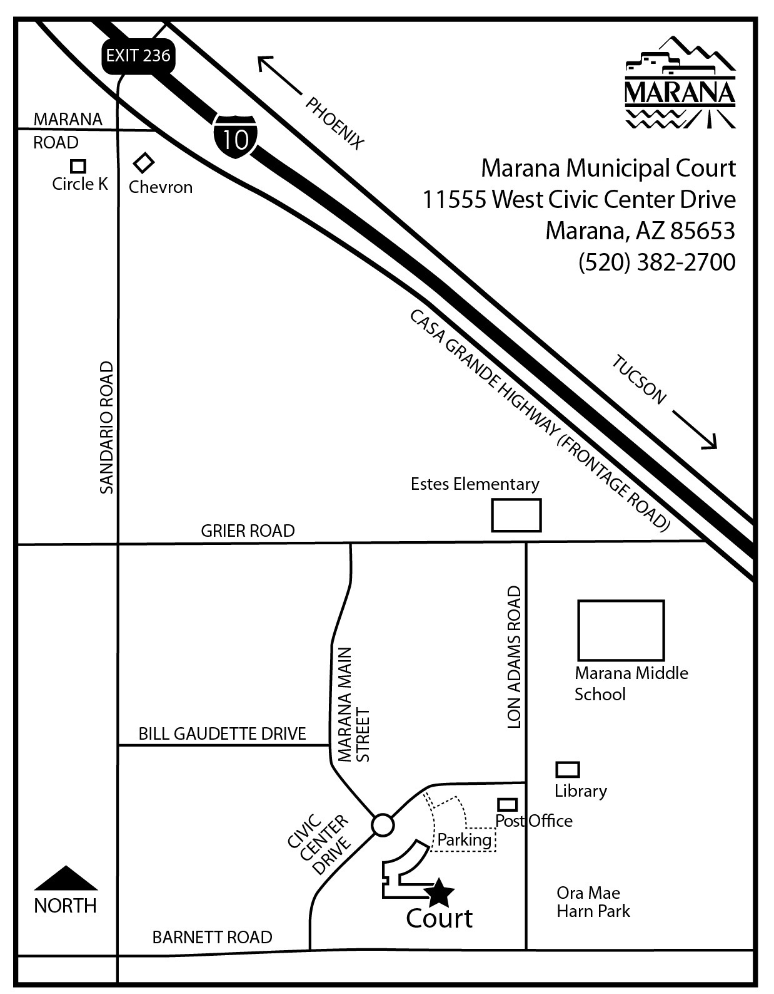
SPEEDING (No Accident)
28-701A ( 1 thru 10 miles over) $170
28-701A (11 thru 15 miles over) $217
28-701A (16 thru 20 miles over) $235
28-701A (21 thru 25 miles over) $255
28-701A (26 thru 30 miles over) $267
28-701A (31 thru 45 miles over) $385
28-702.01A (Waste of Finite Resources) $ 74
SPEEDING (With Accident)
28-701A (Failure to Control Speed) $177
SPEEDING IN HIGHWAY WORK ZONE
28-710A (No workers present) $211
28-710B (Workers present) $298

** If you plead responsible for Red Light Violation, 28-645A or 28-647, Motor Vehicle Division (MVD) will require you to attend Traffic Survival School (TSS). However, if you are eligible for Defensive Driving School and complete the class, the violation will be dismissed and MVD will not require you to attend TSS.

28-907A* $137
(may be suspended with proof that a child seat
was purchased)
28-2153A * $178
(may be reduced to $87 upon obtaining valid registration and providing proof on or before court date)
28-2158C* $168
(fine suspended upon proof of registration)
28-2532A* $582
(may be reduced to $137 upon obtaining valid AZ registration and providing proof on or before court date)
28-3151A* $178
(may be reduced to $87 upon obtaining valid
license and providing proof on or before court date)
28-3169A* $168
(fine dismissed upon proof of a license)
28-3482A* $300
(may be dismissed upon providing proof of a valid
license after citation was issued or a 39-month driving
record issued by MVD showing license is valid
and providing proof on or before court date)
28-4135A, B,&C* $938
(may be reduced to $160 upon providing proof of a 39-month driving record issued by MVD showing that you have not been found responsible for a violation of this section within the past 24 months or not more than one violation within the past 36 months, and obtaining proof of a six month insurance policy, providing proof with insurance policy number—not a binder—on or before court date)

NOTE: 28-2153, 28-2158, 28-2532, 28-3151 and 28-4135 A, B or C will be dismissed if documents were valid prior to citation issue.
WHEN SUBMITTING PROOF BY MAIL WITH PAYMENT IN FULL, SEND COPIES ONLY. ORIGINALS ARE NOT RETURNED.

MARANA MUNICIPAL COURT
11555 WEST CIVIC CENTER DRIVE, BLDG. C
Marana, Arizona 85653-9505
Phone: (520) 382-2700
Fax: (520) 382-2701
Website: www.maranaaz.gov
Email: court@maranaaz.gov

If you are required to pay fines, penalties, fees or other financial obligations as a result of a judgment of this court and you are unable to pay, bring this information to the attention of court staff or the judge because payments over time or other alternatives may be available. Do not ignore your responsibility to pay, as this may result in additional penalties and costs to you. For more information, contact the court or an attorney or visit the following website (MaranaAZ.gov/municipalcourt).

Si a usted se le exige pagar multas, sanciones, cuotas u otras obligaciones económicas como resultado de una sentencia en este tribunal y no puede pagarlas, avíseles o al personal del tribunal o al juez de su situación porque puede ser posible pagar a plazos o puede existir otra opción. No haga caso omiso de su responsabilidad de pagar, el cual le podría generar nuevas sanciones y costas. Para obtener más información, póngase en contacto con el tribunal o un abogado, o diríjase a la siguiente página web: (MaranaAZ.gov/municipalcourt).
06/26/2019

