TOWN OF MARANA

Employee Self Service (ESS)

Approving Time Off and
Time Entry

A Guide for Supervisors

APPROVING TIME OFF:
Upon submission of leave request, email will be sent to Supervisor:
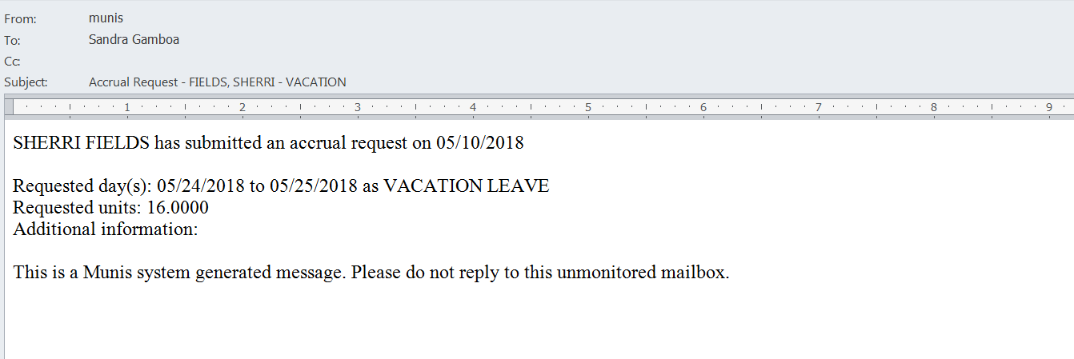
Login to ESS
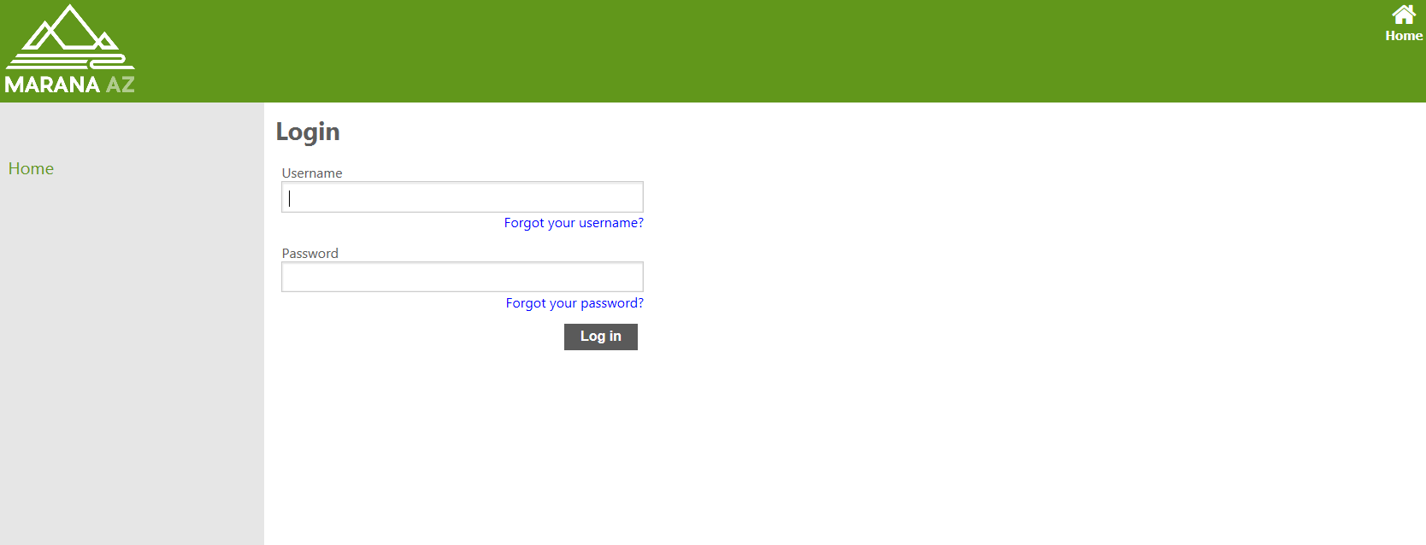
Select Employee Self Service
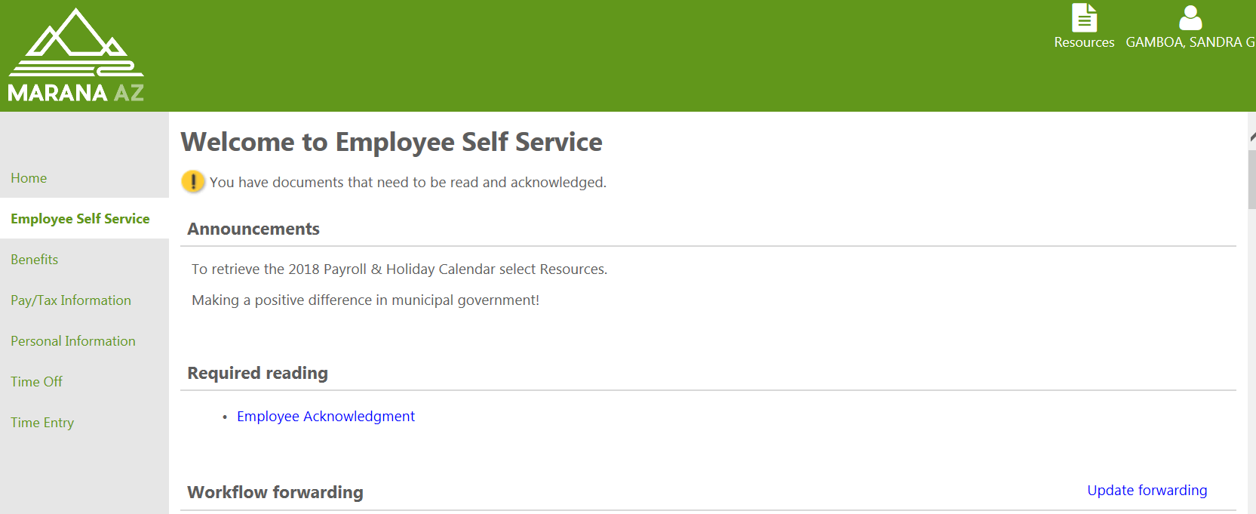

Select Time Off, then Employee Requests
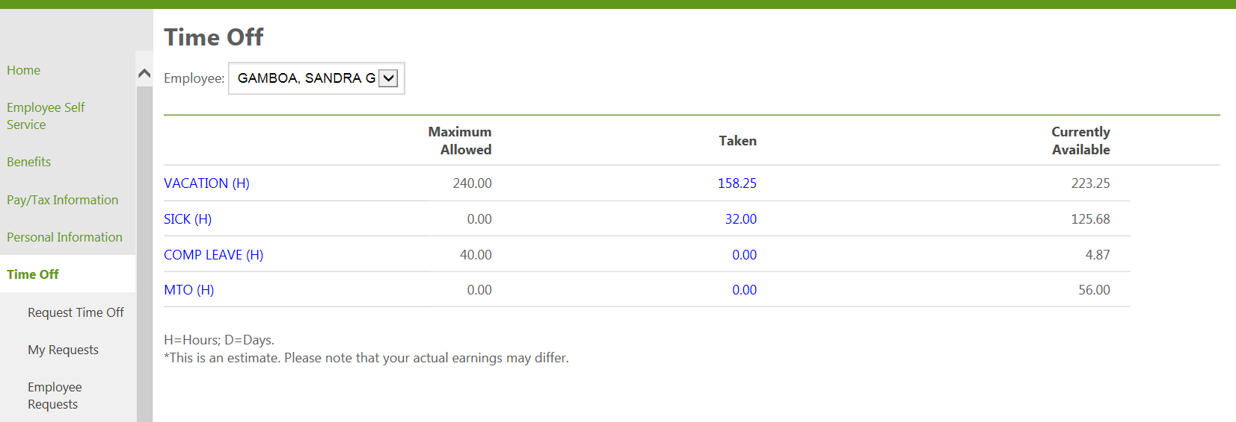

Manage Time Off Requests will populate onto the screen:
Select Approve, Reject, Forward or Hold. A comment is required for rejections.
Supervisor may add to Outlook calendar at this time
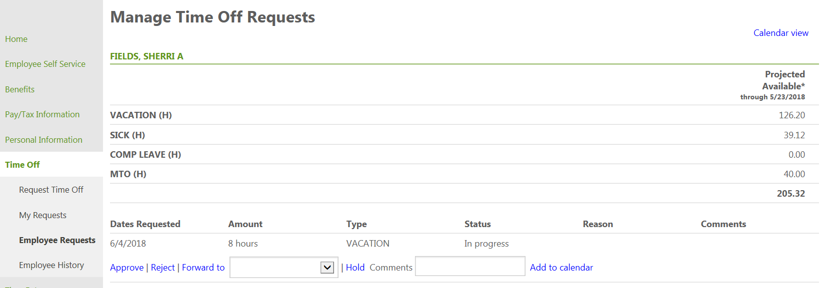
Adding employee request to Outlook calendar: Select Add to calendar
The following will populate on the bottom of the screen. Select open
Outlook will populate as illustrated below. Any part of of the outlook appointment can be modified if needed. Select Save & Close
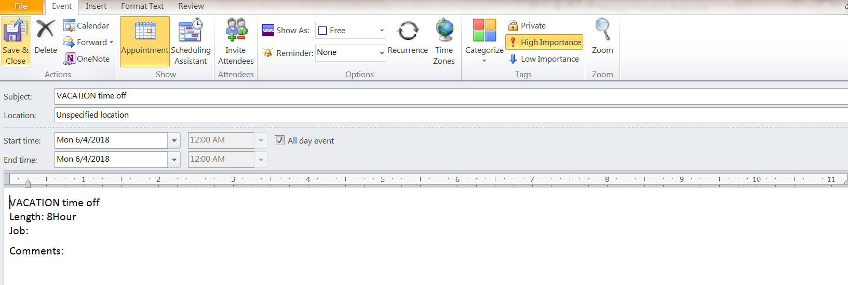
Outlook Calendar will be updated as illustrated below:
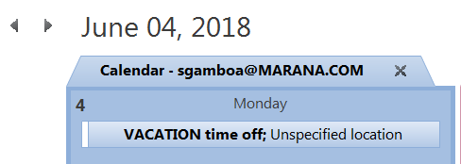
Once approved Employee will receive the following email:
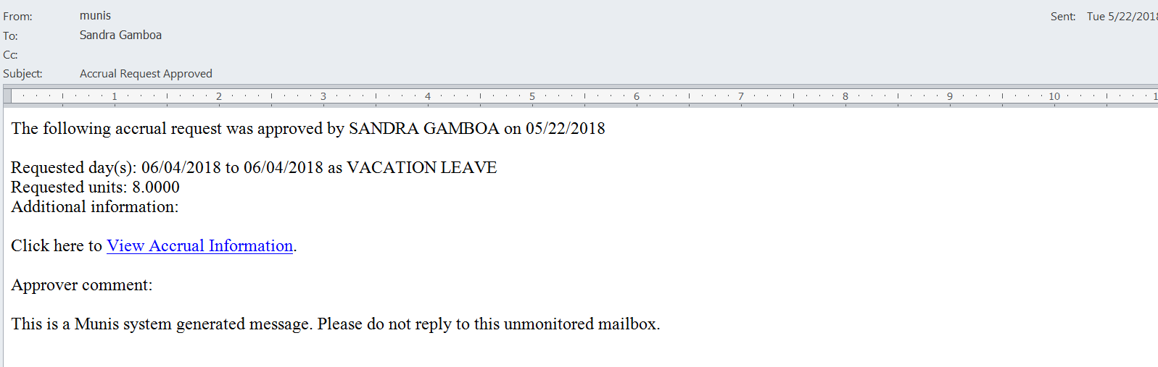

YOU HAVE COMPLETED THE LEAVE APPROVAL PROCESS

APPROVING TIME ENTRY:
Upon submission of Time Entry from your non-exempt employee, an email will be sent to Supervisor:
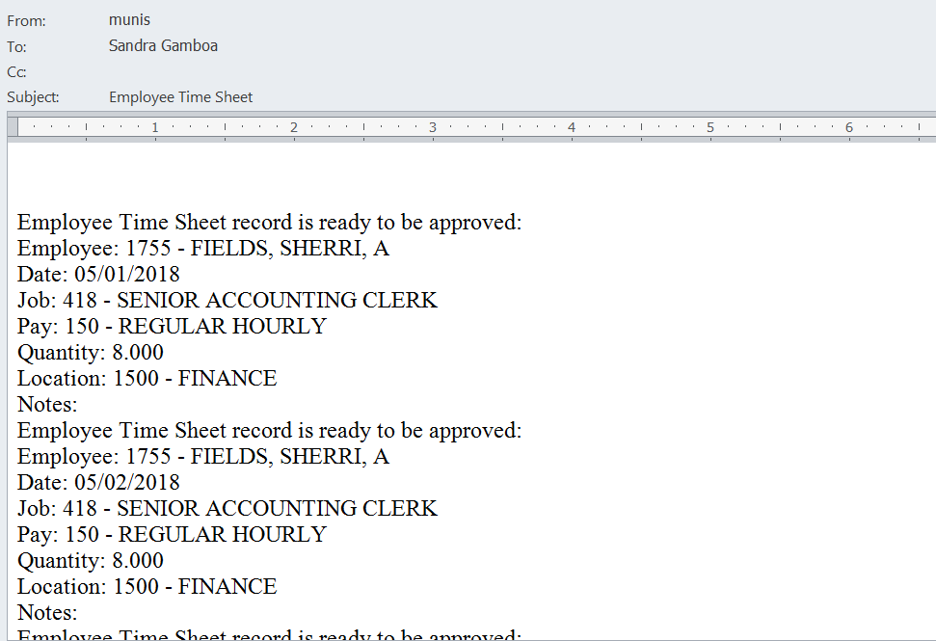
Login to ESS
Select Time Entry. You will be directed to Pending Timesheets (Supervisor landing page):
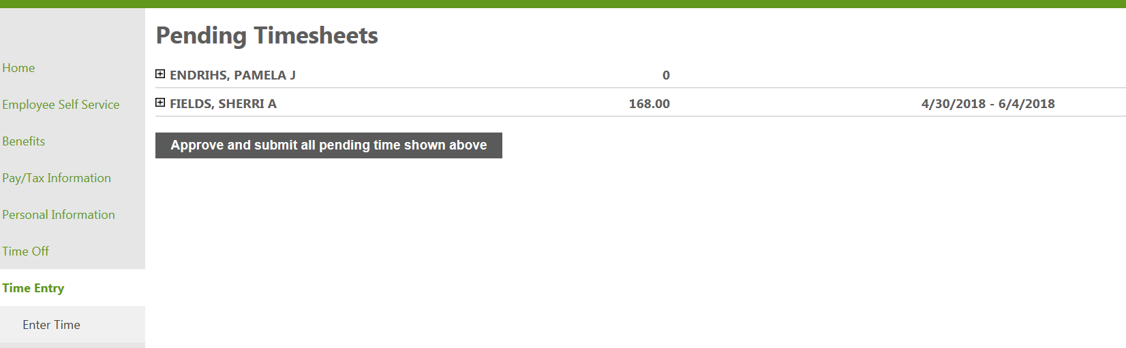
Supervisor should drill down to review entry. Select Details to review timesheet for each employee:
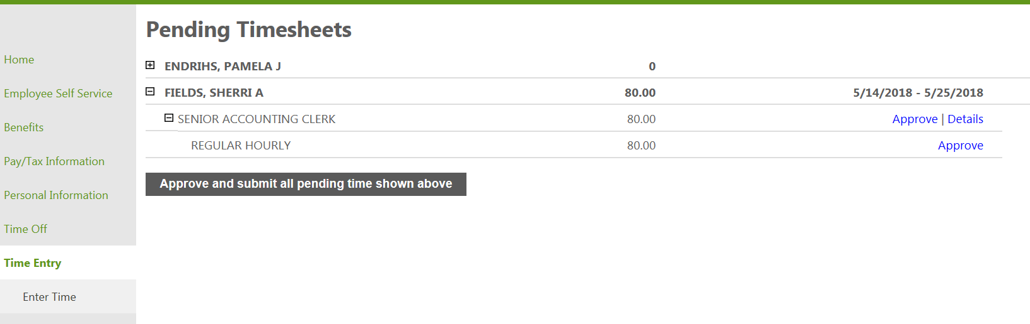
Supervisor will be directed to timesheet. Review each week of the pay period. If no changes, select to direct back to Pending Timesheets. If adjustment is needed select Edit, then Submit: This does not approve timesheet
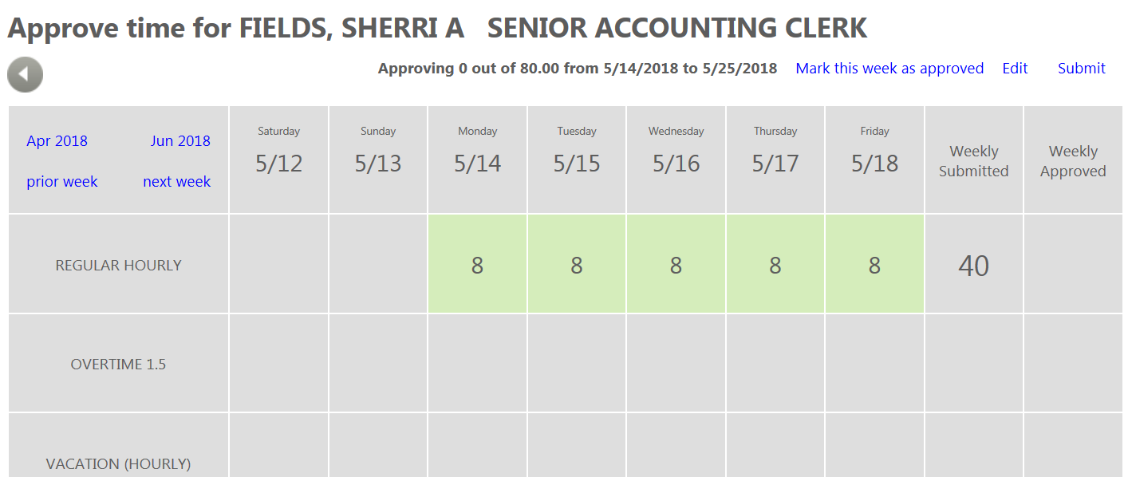

TO EDIT TIMESHEET:
Select specific date on timesheet and select Edit. The following will display:
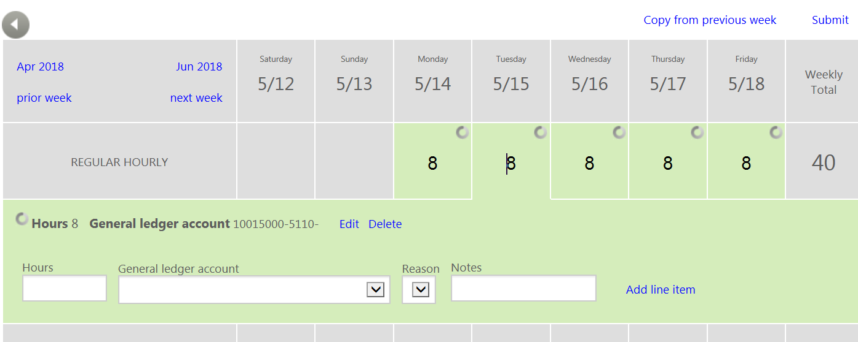
Make changes as needed. Select Save then Submit Please note: not all departments will have the General ledger account field.
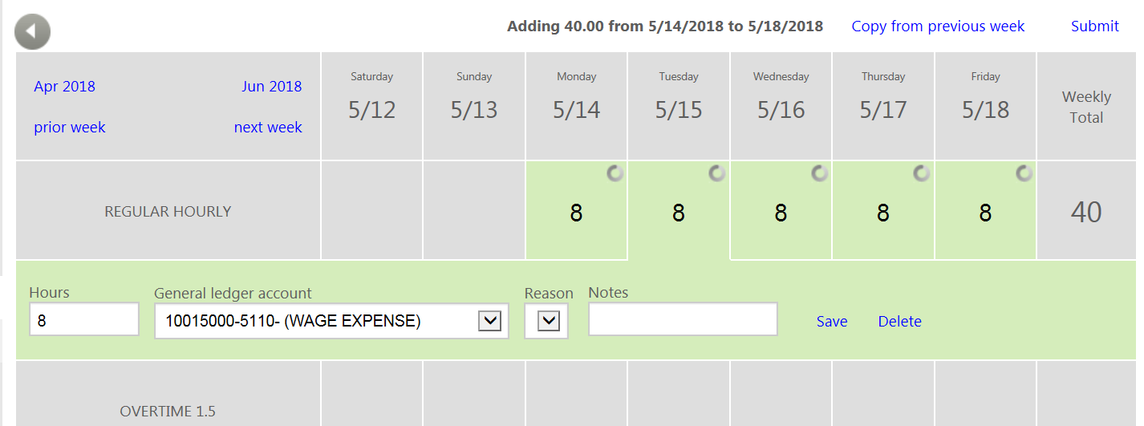
You will be directed back to Pending Timeshetts (Supervisors landing page)
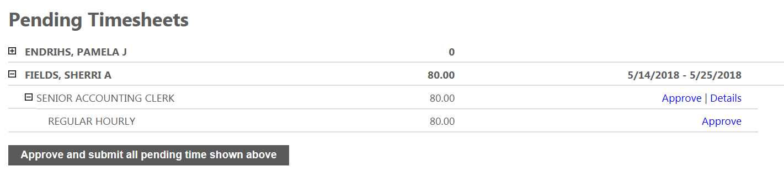
Upon review of ALL timesheets, select Approve and submit all pending time shown above
YOU HAVE COMPLETED THE TIMESHEET APPROVAL PROCESS
IMPORTANT INFORMATION:
- EXEMPT EMPLOYEES:
  - Leave Requests are required through ESS
    - Planned – prior to taking leave
    - Unplanned – from remote computer or upon return to work
  - Do not submit Timesheets
  - Approval of Timesheet is not required for Exempt employees
  - In order to change hours that were pre-approved, Employee must cancel and re-submit.
  - If adjustments are needed after Payroll has been processed – Employee must complete and sign an Adjustment Attendance Record for Exempt employees and submit to Payroll office as soon as possible. Supervisor signature is required.
- NON-EXEMPT EMPLOYEES
  - Leave Requests are required for Vacation, MTO, Compensatory, Sick, Bereavement and Civic Duty.
    - Planned – prior to taking leave
    - Unplanned – from remote computer or upon return to work
  - Hours entered on Timesheet:
    - Regular hours, Overtime, Overtime Accrue, Shift, On-call and Holiday
  - When a pre-approved leave has been populated on timesheet and employee has worked more hours than regularly scheduled for the week, leave shall be reduced. Employee must navigate to My Requests and select Cancel.
    - Re-submit a leave request with the reduced hours to bring to 40 hours for the week.
  - If adjustments are needed after Payroll has been processed – Employee must complete and sign an Adjustment Non-Exempt Timesheet Record and submit to Payroll office as soon as possible. Supervisor signature is required.
- DEADLINES:
  - It is important to meet the approval deadlines set each pay period. This is crucial in receiving your paycheck on-time.

